**SREE NARAYANA GURU COLLEGE OF COMMERCE**

**P. L. LOKHANDE MARG, CHEMBUR, MUMBAI - 400089**

**Report**

**Date: 06th August ,2023**

**Event name: Trekking**

**Venue – Karnala Bird Sanctuary, Panvel.**

**Timings – 6 am to 6 pm**

Sports Committee has organized Trekking on 06th August,2023 at Karnala Bird Sanctuary, Panvel. We had booked 2 buses. Students had to report to college at 6 am in college ground. Started our way to Karnala Bird Sanctuary at 7 am. After reaching to Karnala Bird Sanctuary, started walking and climbing to reach to the peak point. For the trekkers the Karnala Fort Trail is the best. The bird sanctuary is a popular destination for bird-watchers and hikers in the Mumbai area. The Sanctuary area is covered with mixed deciduous forest. The Shiva temple is situated near to Karnala bird sanctuary is a popular Shiva temple worshipped by the devotees on a large. Saw peacock dancing, rabbits , mongoose & some colourful birds singing. Monsoon provides the best climate and the best views full of clouds.

It took 2 hours to climb to the peak point. Point is full of nature and adventurous view. It was an adventurous activity for the students. Students helped each other to climb and descend the mountain. Although it was raining, students were full of spirit and happy. Students learnt the value of Team work because it is not possible to reach the top of the mountain without working together. All students reached home safely. The feedback form was circulated after the event. All the students gave Excellent Feedback. Students were asking for more such activities. Total 70 students were on Trekking with 2 faculties: Sports Incharge Mrs. Punam Mujwar and Ms. Nahid Shaikh (Sports committee member) and Gymkhana Incharge Mr. Sachin Lembhe.

It was really an adventurous and amazing experience.

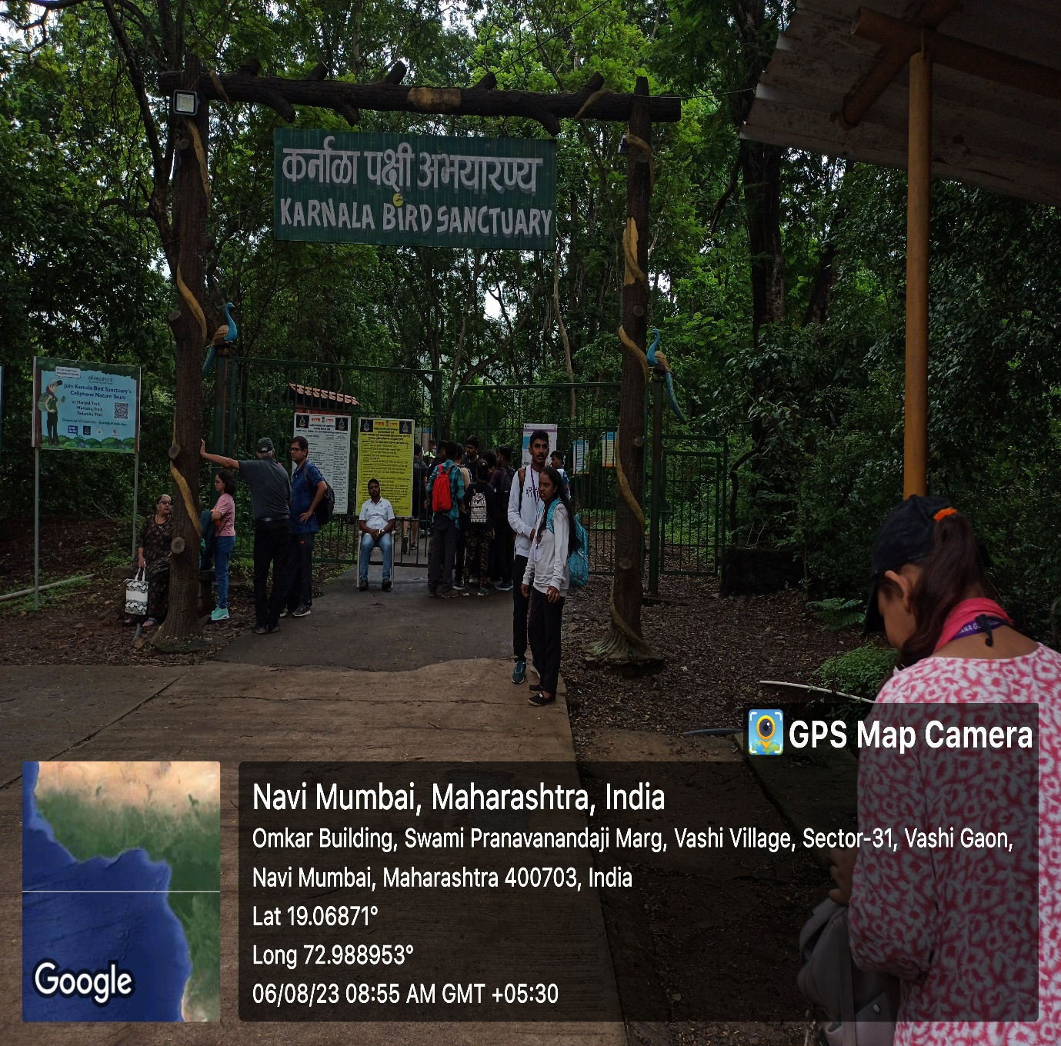

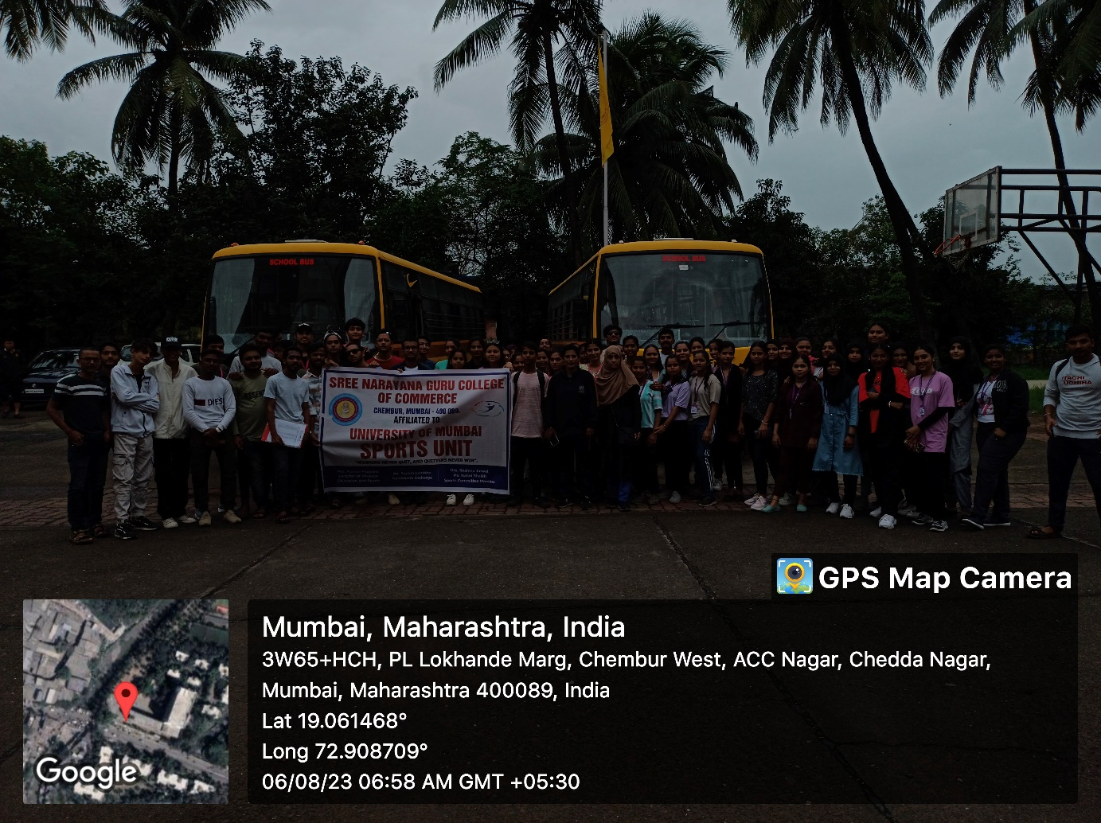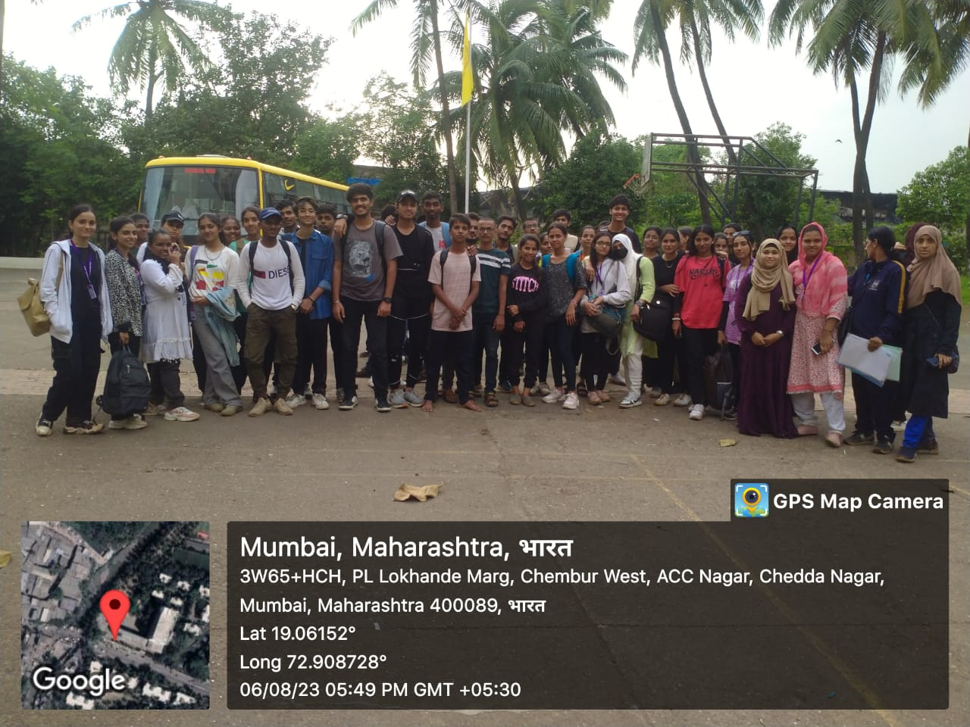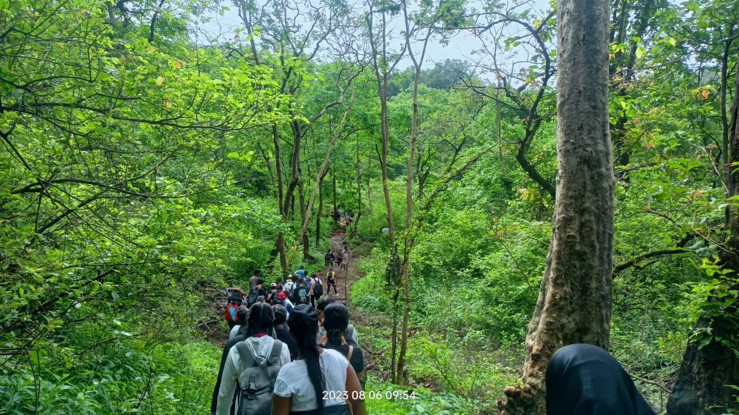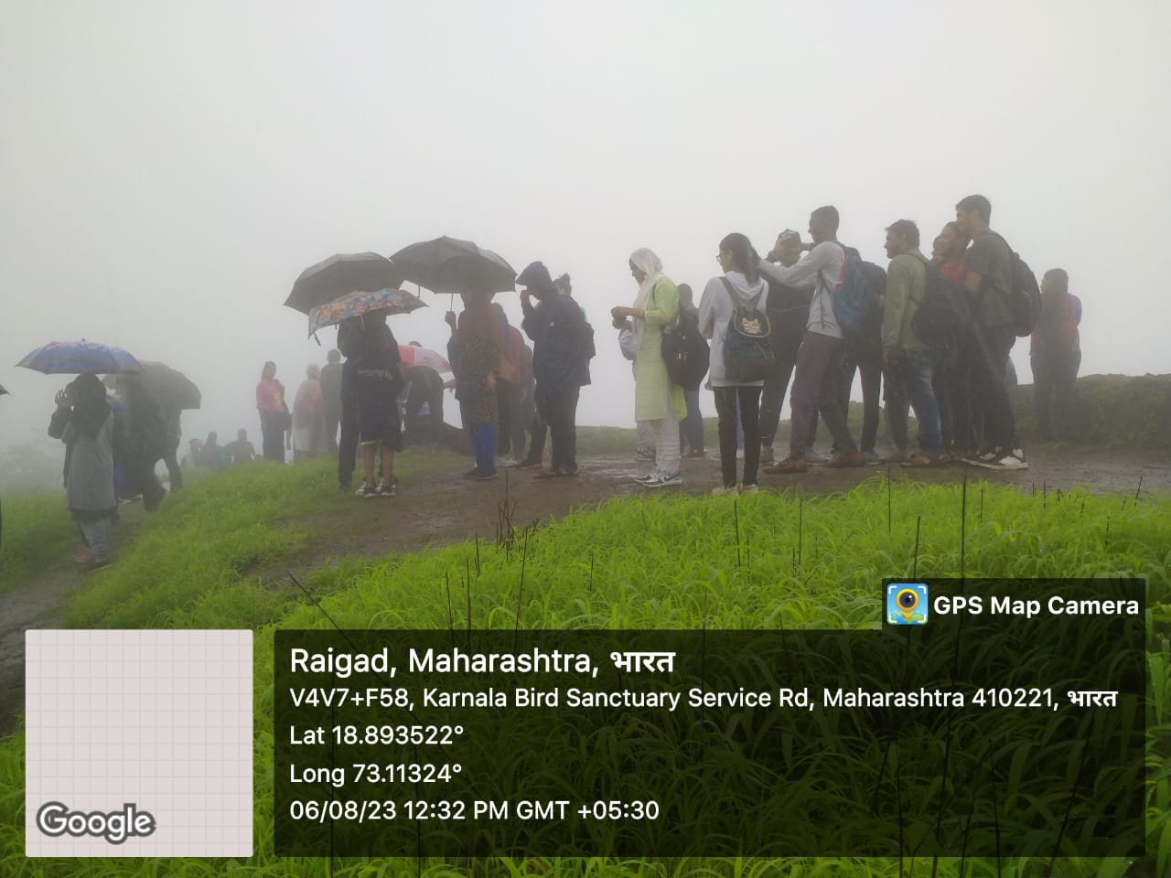

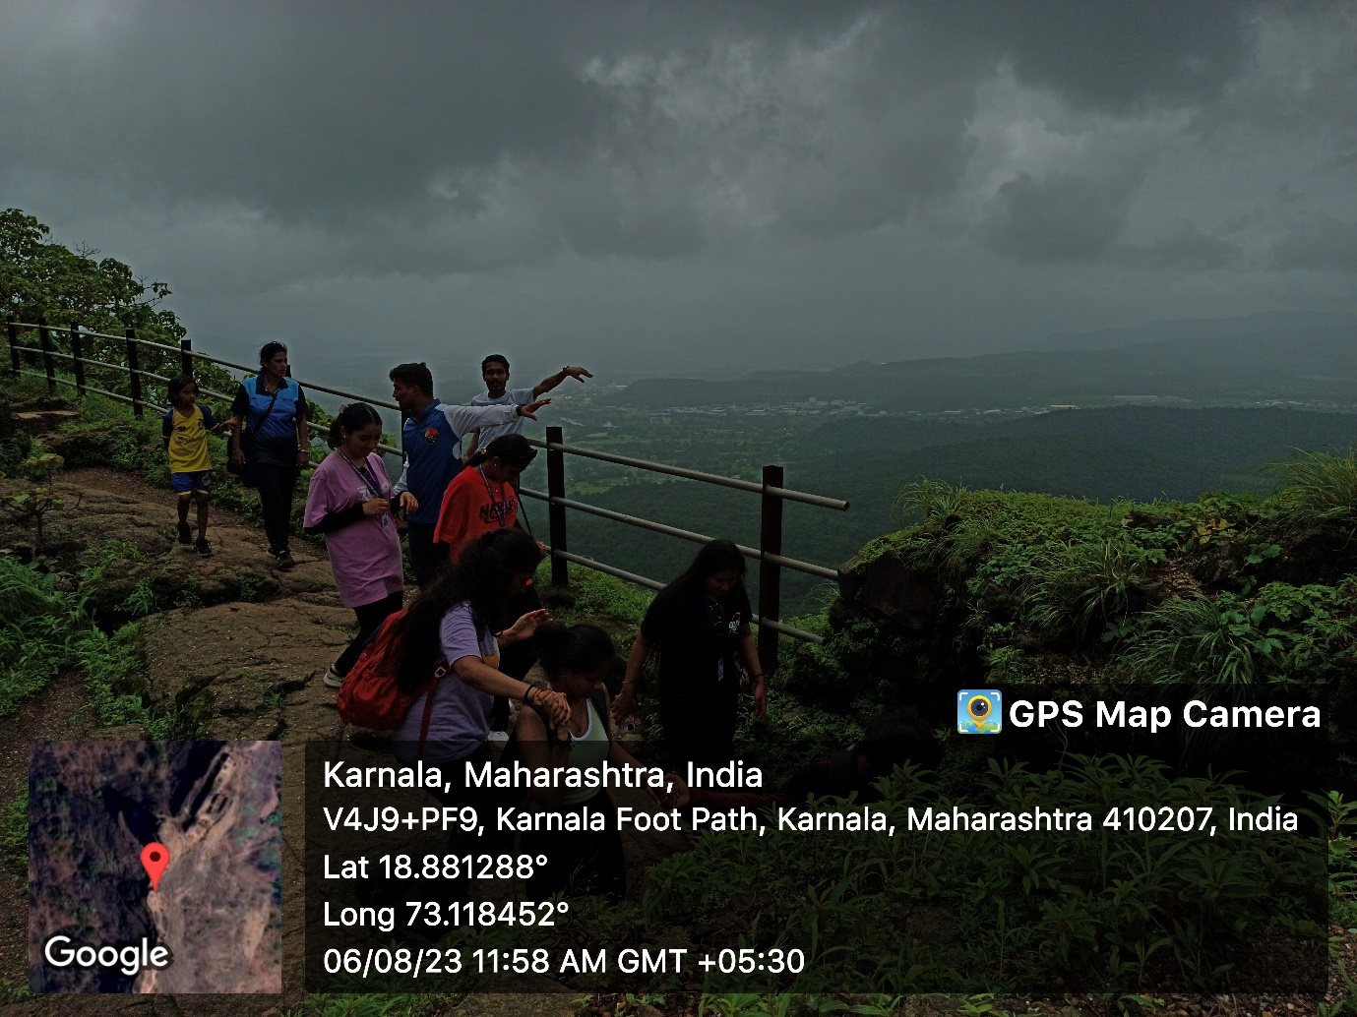

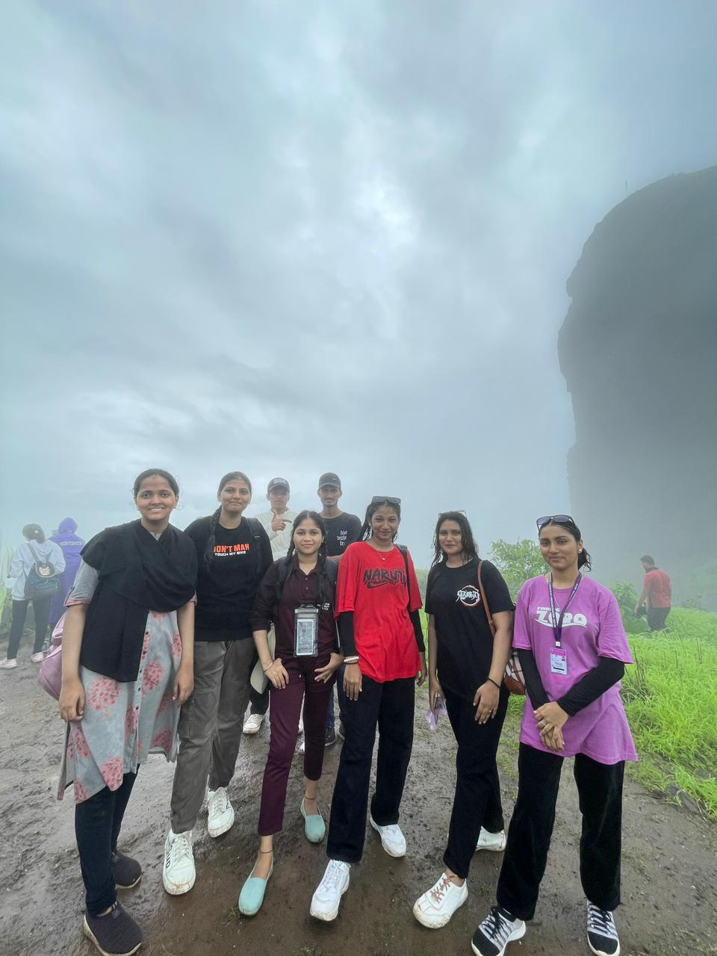

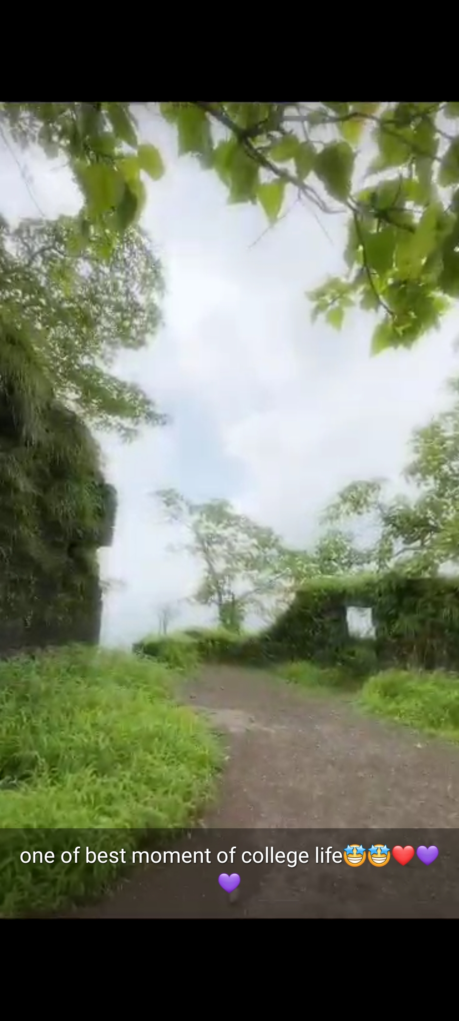

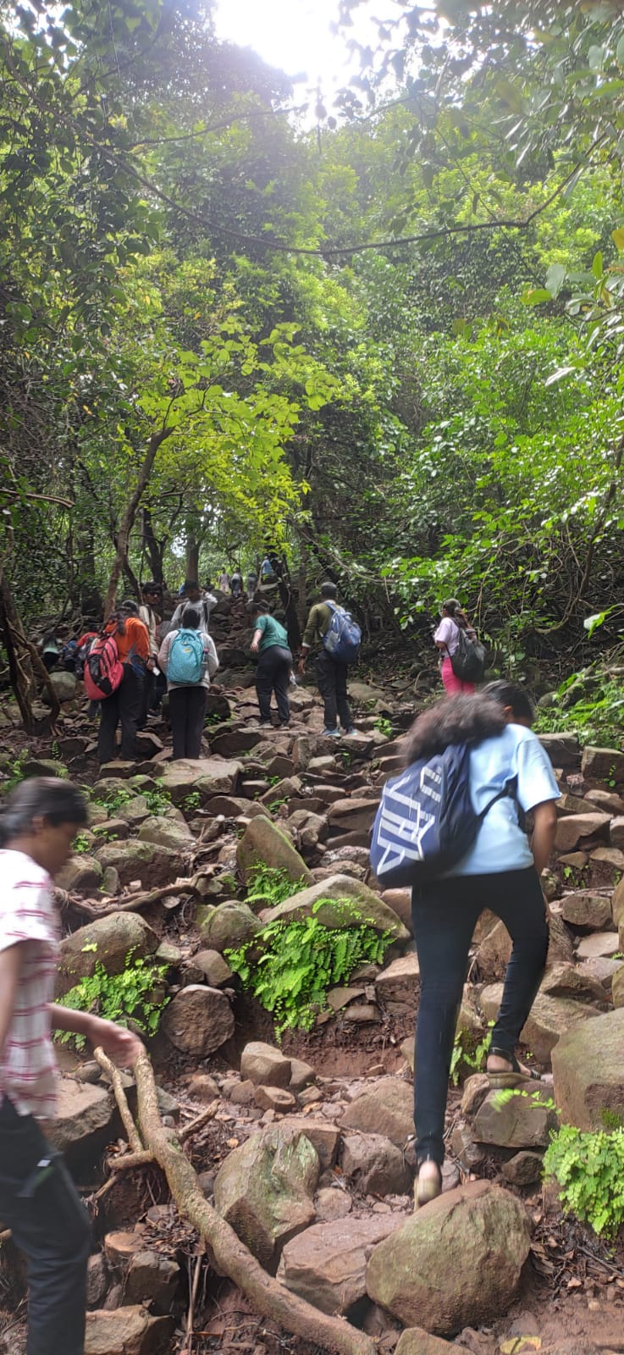

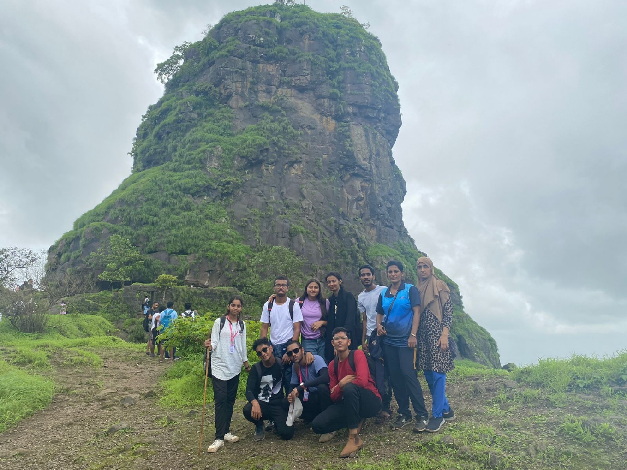

**Regards,**

**Mrs. Punam Mujawar**

**Sports Incharge**